**The Jenkins Plugin Manager**

* Jenkins derives most of its power from plugins. A plugin is a piece of software that upon installation will enhance the Jenkins functionality.
* Jenkins Plugin Manager 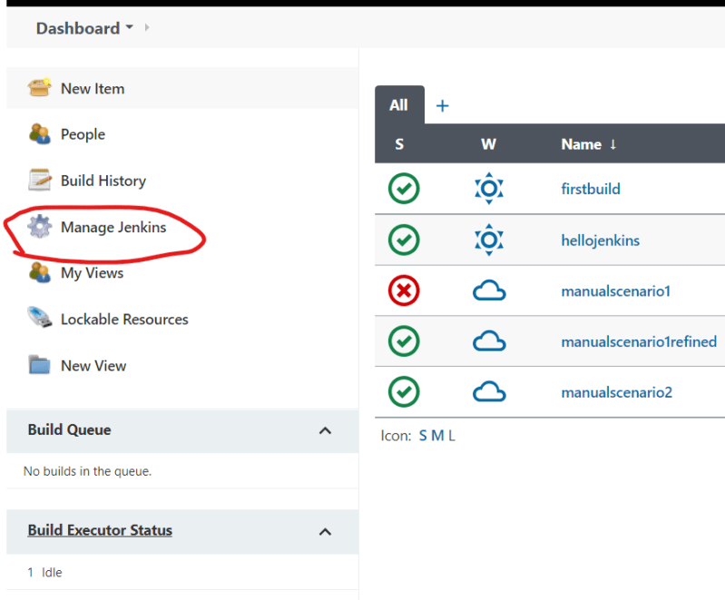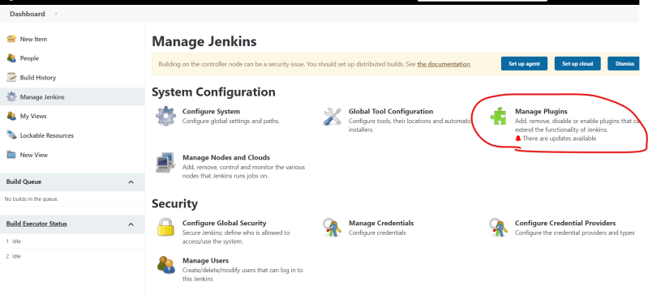

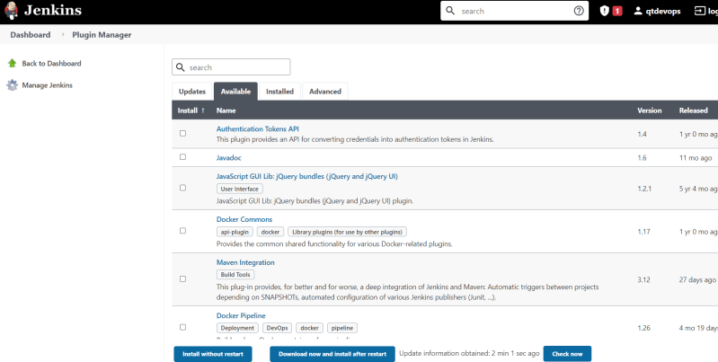

* Updating existing plugins 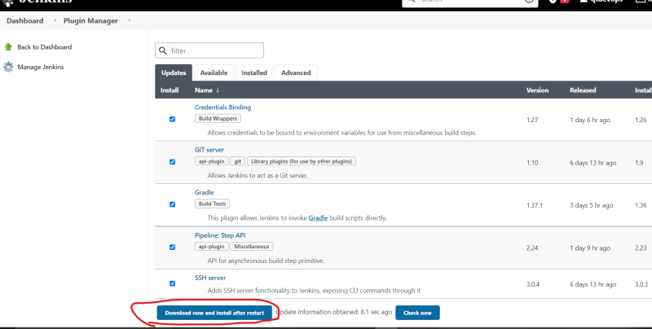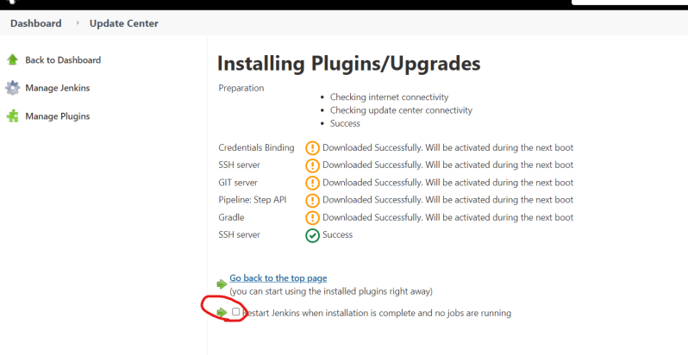
* Installing plugins 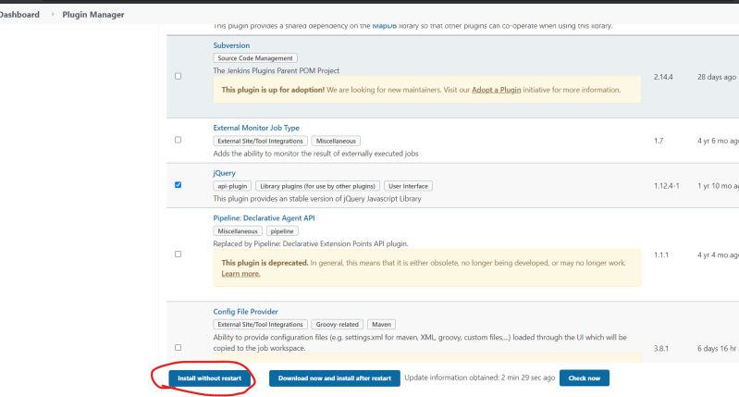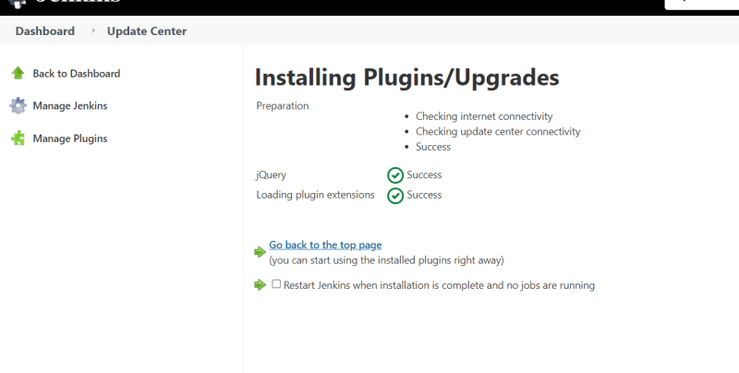
* Lets assume your organization is using subversion as version control system 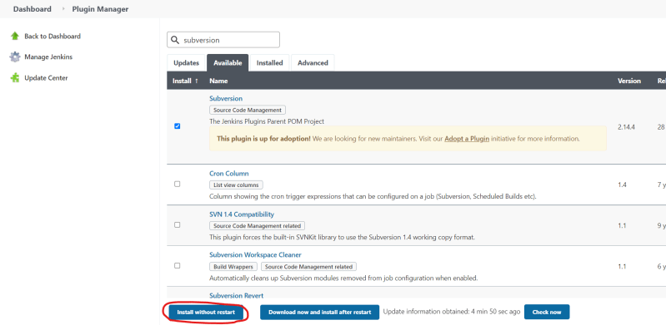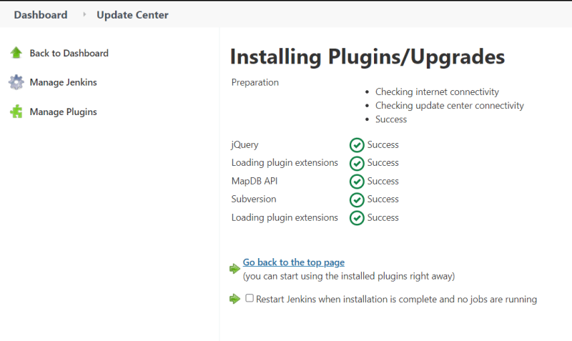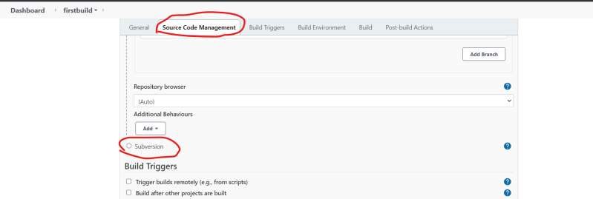
* Manually installing a Jenkins Plugin:
  + In Some cases we need to install the Jenkins Plugin
  + Jenkins plugins file extension will be of type .jpi (jenkins plugin interface) or .hpi (hudson plugin interface) 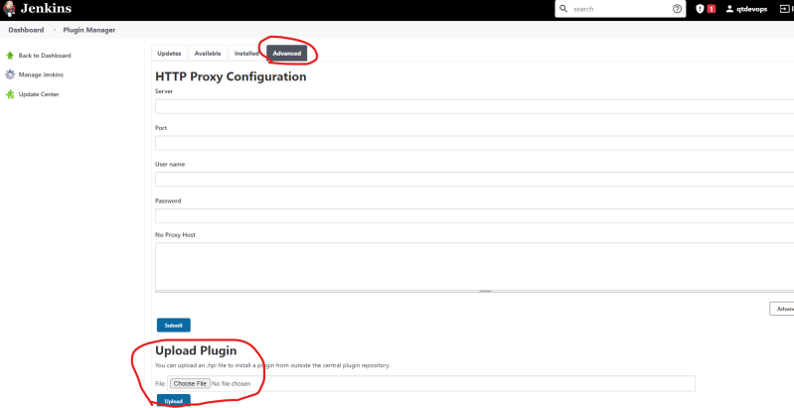
* Jenkins plugin index [Refer Here](https://plugins.jenkins.io/)

**Jenkins Backup and restore**

* All of the Jenkins data is stored in the Jenkins home directory
  + /var/lib/jenkins
* Most Easiest way of taking backup is create a sync of Jenkins home directory in some other system
* Sample Highly Available Jenkins setup 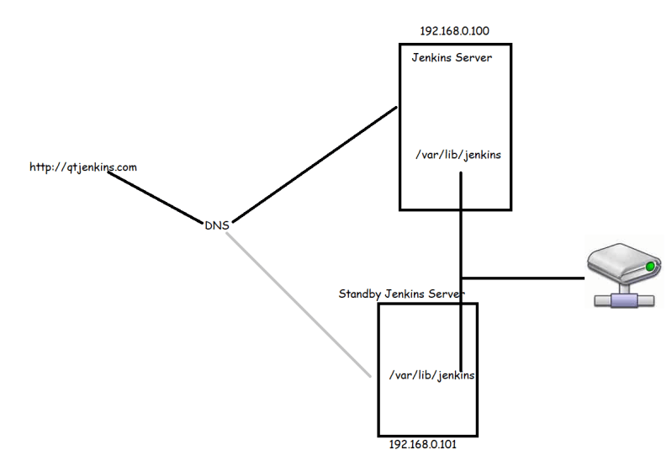
* Periodic Backups of Jenkins using Plugins 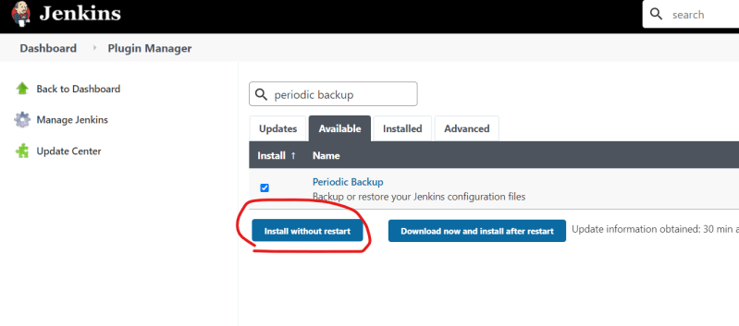
* Configuring periodic backup
  + Manage Jenkins => Periodic Backup Manager 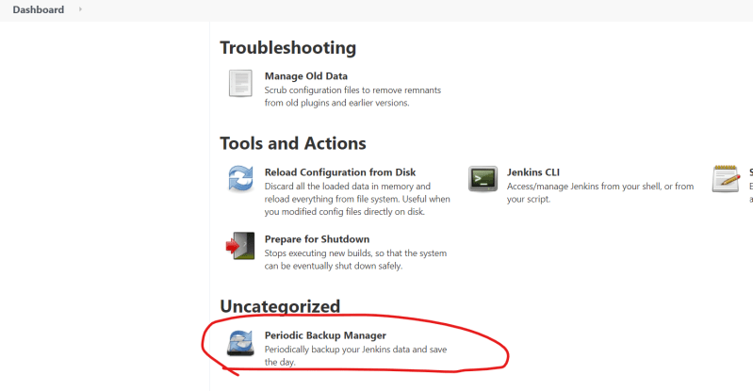
  + Now click configure and ensure we have a folder for backups and provide the information as discussed in the class.